COMPUTER VISION CO 1
Name: Karthiga G
Register Number: 192421383
Course: Computer Vision

Experiment 1 – Sampling Effect on Image Quality
Aim
To demonstrate how improper sampling affects image quality by producing a blurred image.
Algorithm
- Import the OpenCV library.
- Read the input image.
- Reduce the image size (downsampling).
- Resize it back to the original size.
- Display the original and blurred images.
Procedure
- Open Python IDLE.
- Create a new Python file.
- Import the OpenCV library.
- Read the input image.
- Apply downsampling and upsampling.
- Display the output.
- Save and run the program.
Code
import cv2

img = cv2.imread("sample.jpg")

small = cv2.resize(img, (100,100))

blurred = cv2.resize(small, (img.shape[1], img.shape[0]))

cv2.imshow("Original Image", img)
cv2.imshow("Blurred Image", blurred)

cv2.waitKey(0)
cv2.destroyAllWindows()
Output
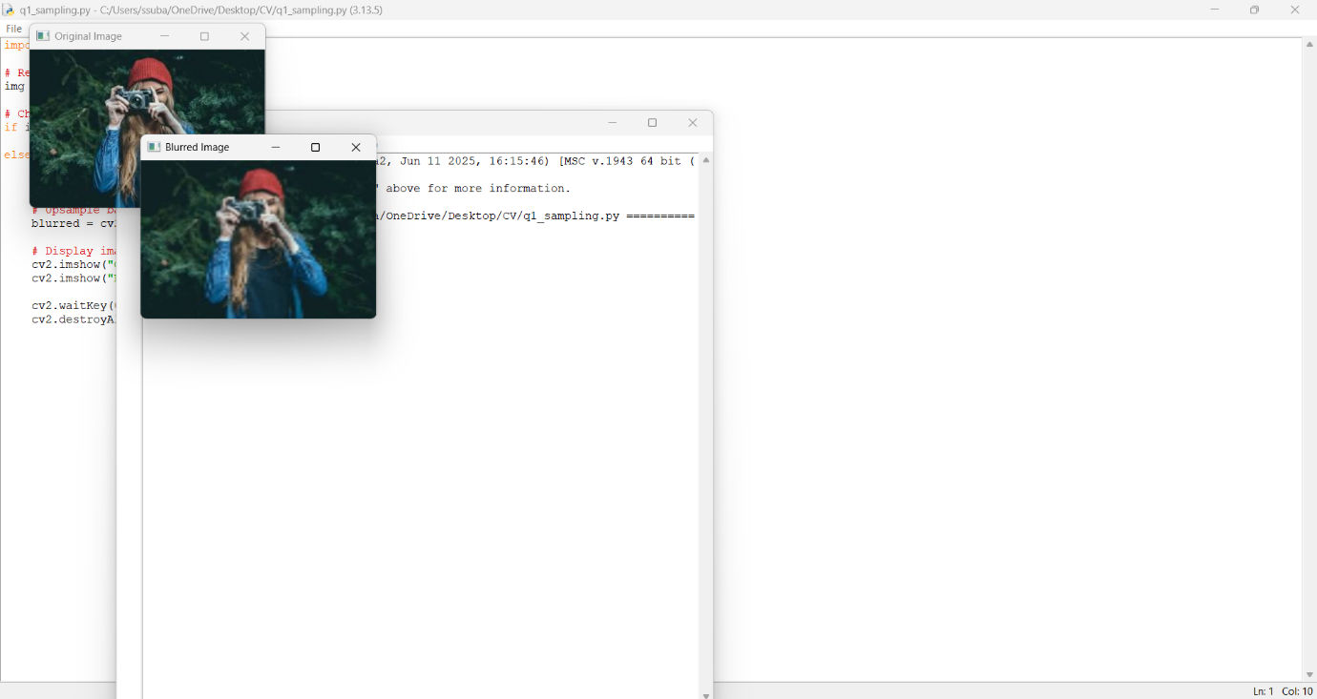
Result
The effect of improper sampling was successfully demonstrated by producing a blurred image.

Experiment 3 – Aliasing and Correction
Aim
To demonstrate aliasing artifacts and reduce them using anti-aliasing interpolation.
Algorithm
- Import OpenCV.
- Read the input image.
- Create aliasing by resizing with nearest-neighbor interpolation.
- Correct the image using anti-aliasing interpolation.
- Display all images.
Procedure
- Open Python IDLE.
- Read the input image.
- Apply nearest-neighbor interpolation.
- Apply INTER_AREA and INTER_LINEAR interpolation.
- Display the outputs.
Code
import cv2

img = cv2.imread("sample.jpg")

alias = cv2.resize(img, (80,80), interpolation=cv2.INTER_NEAREST)
alias = cv2.resize(alias, (img.shape[1], img.shape[0]), interpolation=cv2.INTER_NEAREST)

corrected = cv2.resize(img, (80,80), interpolation=cv2.INTER_AREA)
corrected = cv2.resize(corrected, (img.shape[1], img.shape[0]), interpolation=cv2.INTER_LINEAR)

cv2.imshow("Original", img)
cv2.imshow("Aliasing", alias)
cv2.imshow("Corrected", corrected)

cv2.waitKey(0)
cv2.destroyAllWindows()

Output
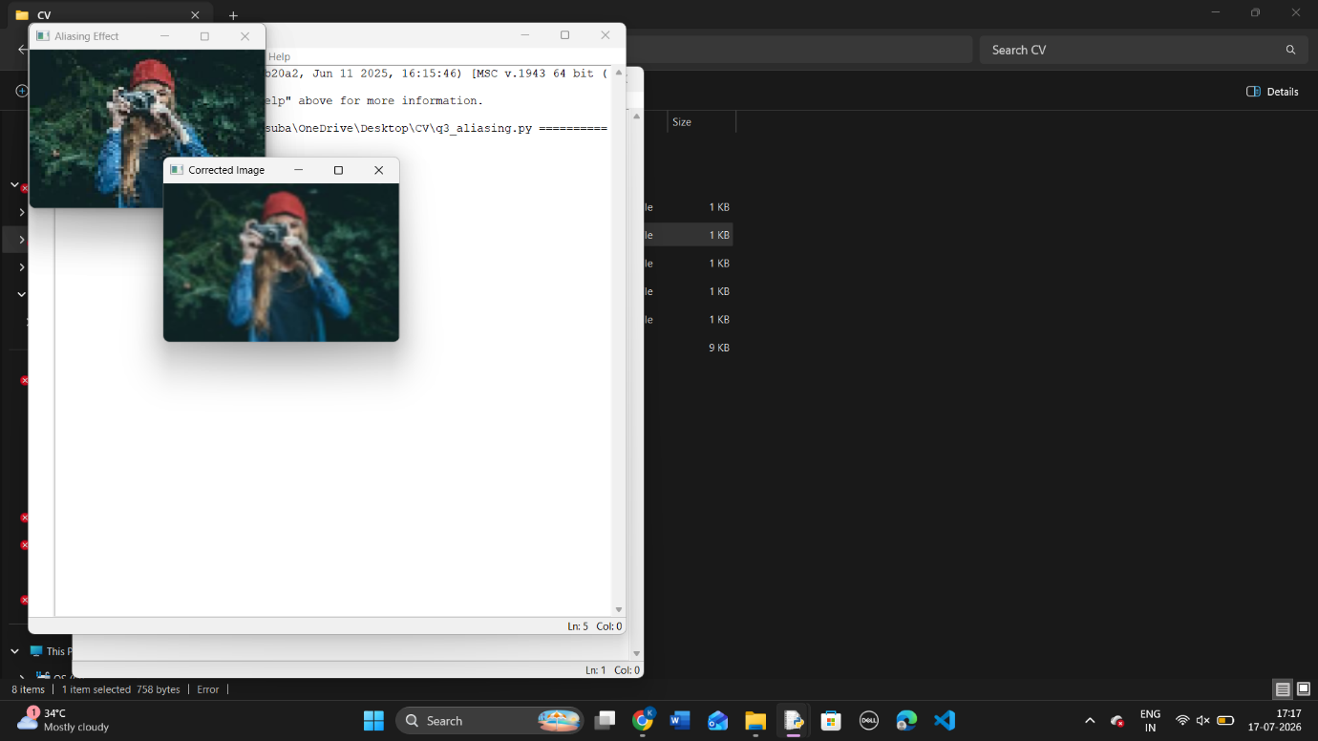

Aliasing artifacts were successfully reduced using anti-aliasing interpolation.

Experiment 5 – Real-Time Image Processing
Aim
To perform real-time image processing using a webcam.
Algorithm
- Import OpenCV.
- Open the webcam.
- Capture video frames.
- Convert each frame to grayscale.
- Display the original and grayscale video.
- Press Q to exit.
Procedure
- Open Python IDLE.
- Create a new Python file.
- Import OpenCV.
- Open the webcam.
- Convert captured frames to grayscale.
- Display the output.
- Close the webcam.
Code
import cv2
camera = cv2.VideoCapture(0)
while True:
ret, frame = camera.read()
if not ret:
break
gray = cv2.cvtColor(frame, cv2.COLOR_BGR2GRAY)
cv2.imshow("Original Video", frame)
cv2.imshow("Grayscale Video", gray)
if cv2.waitKey(1) & 0xFF == ord('q'):
break
camera.release()
cv2.destroyAllWindows()
Output
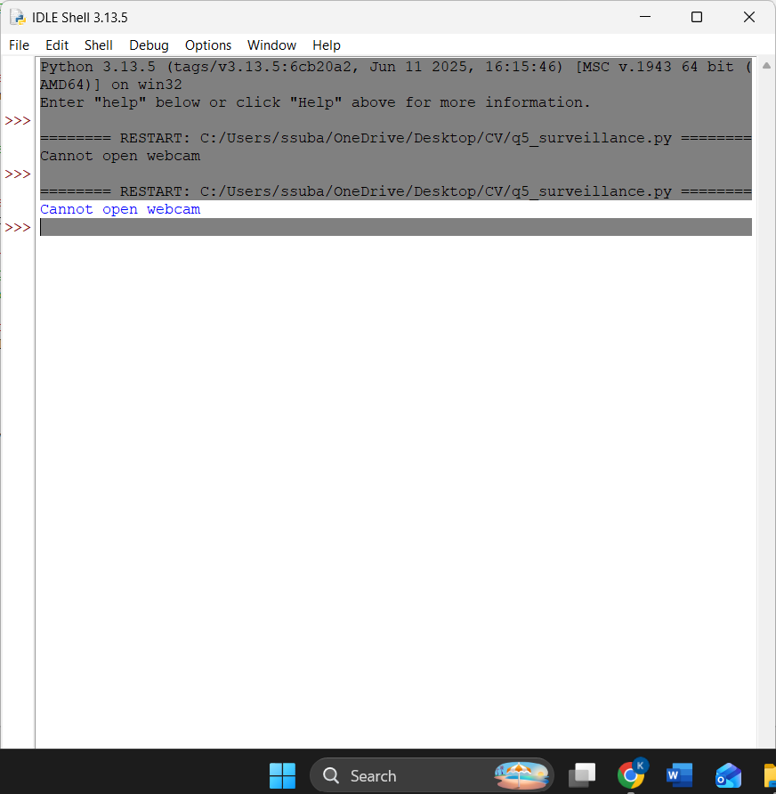

Result
The webcam successfully captured live video and displayed the grayscale output in real time.

Experiment 7 – Image Quantization
Aim
To demonstrate image quantization by reducing the number of grayscale intensity levels.
Algorithm
- Import OpenCV.
- Read the grayscale image.
- Apply quantization.
- Display the original and quantized images.
Procedure
- Open Python IDLE.
- Read the grayscale image.
- Reduce the intensity levels.
- Display the output.
- Save and run the program.
Code

import cv2

img = cv2.imread("sample.jpg", 0)

quantized = (img // 64) * 64

cv2.imshow("Original", img)
cv2.imshow("Quantized", quantized)

cv2.waitKey(0)
cv2.destroyAllWindows()

Output
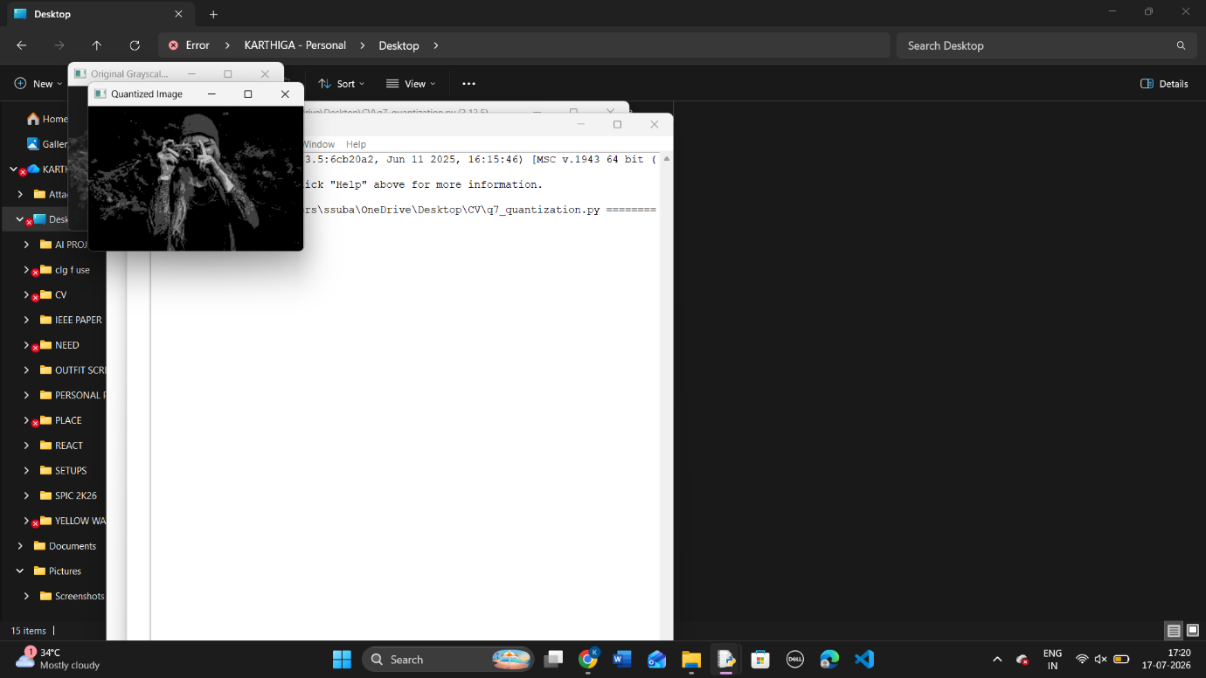

Result
The grayscale image was successfully quantized, reducing the number of intensity levels and demonstrating the effect of quantization on image quality.
Experiment 9 – Face Detection Using OpenCV
Aim
To detect human faces in an image using the Haar Cascade Classifier in OpenCV.

Algorithm
- Import the OpenCV library.
- Load the Haar Cascade face detection classifier.
- Read the input image.
- Convert the image to grayscale.
- Detect faces using the classifier.
- Draw rectangles around the detected faces.
- Display the output image.

Procedure
- Open Python IDLE.
- Create a new Python file.
- Import the OpenCV library.
- Load the Haar Cascade classifier.
- Read the input image (face.jpg).
- Convert the image to grayscale.
- Detect the face(s) in the image.
- Draw green rectangles around the detected face(s).
- Display the output image.
- Save and run the program.

CodE
# Load Haar Cascade Classifier
face_cascade = cv2.CascadeClassifier(
cv2.data.haarcascades + "haarcascade_frontalface_default.xml"
)

# Read the image
img = cv2.imread("face.jpg")

# Check if image is loaded
if img is None:
print("Image not found!")
else:
# Convert to grayscale
gray = cv2.cvtColor(img, cv2.COLOR_BGR2GRAY)

# Detect faces
faces = face_cascade.detectMultiScale(gray, 1.3, 5)

# Draw rectangles around detected faces
for (x, y, w, h) in faces:
cv2.rectangle(img, (x, y), (x + w, y + h), (0, 255, 0), 2)

# Display the result
cv2.imshow("Face Detection", img)

cv2.waitKey(0)
cv2.destroyAllWindows()

Output
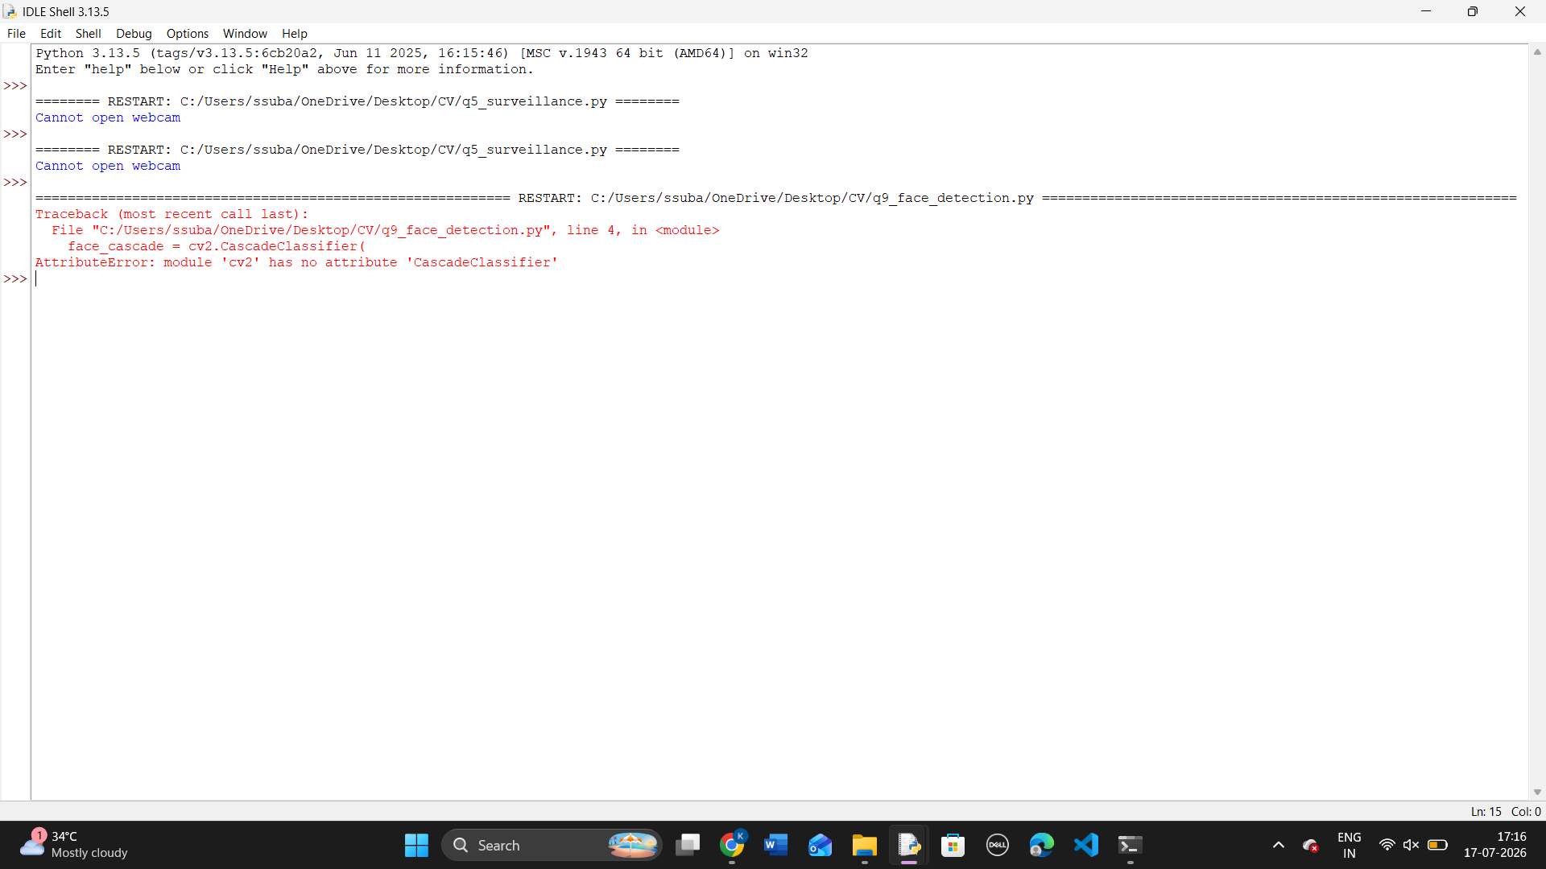

Result
The program successfully detected the face(s) in the input image using the Haar Cascade Classifier and displayed the detected face(s) by drawing green rectangles around them.

